**Lab 01: MARS tutortial.**

*Perla Vanessa Jaime Gaytán*

*A003444428*

*August 28th, 2020.*

**Lab work**

The following sections describe two basic exercises for understanding both MARS and MIPS assembly language.

1. **Exercise 1 - 40%**

Create a copy of Fibonacci.asm and name it Fibonacci_reverse.asm. This version of the program should accomplish the following specifications.

1. Compute the first 20 numbers of the Fibonacci series.
2. Print out the Fibonacci series in reverse order, i.e., your program should start by printing the value 6765 and finish with the value.

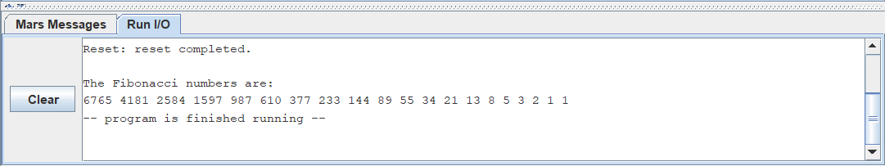

1. **Exercise 2 - 60%**

The objective of this exercise is to translate a piece of high-level language pseudo-code into assembly language. Your task is to generate an assembly language program that implements the pseudo-code of Listing 1.

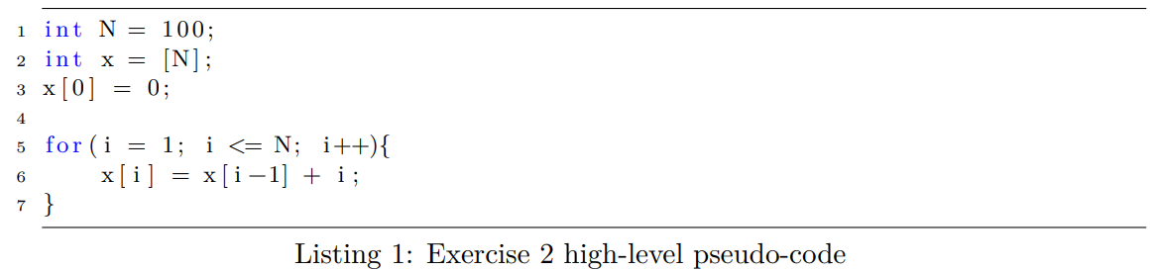

Your program should compute and place all values of x in contiguous memory addresses. Additionally, your program should print all values of x in the Run I/O panel using syscall instructions.

